
0000.doc

PHYSICS SAMPLE EXAMINATION 3A/3B

Section 7 of the New WACE Manual: General Information 2006–2009 outlines the policy on WACE examinations.

Further information about the WACE Examinations policy can be accessed from the Curriculum Council website at
http://newwace.curriculum.wa.edu.au/pages/about_wace_manual.asp

The purpose for providing a sample examination is to provide teachers with an example of how the course will be examined. Further finetuning will be made to this sample in 2007 by the examination panel following consultation with teachers, measurement specialists and advice from the Assessment, Review and Moderation (ARM) panel.




Western Australian Certificate of Education, Sample External Examination

Question/Answer Booklet

PHYSICS 3A/3B
Please place your student identification label in this box
WRITTEN PAPER
STAGE 3

Student Number: In figures

In words

Time allowed for this paper
Reading time before commencing work: Ten minutes
Working time for paper: Three hours

Material required/recommended for this paper

To be provided by the supervisor
This Question/Answer Booklet; Formulae and Constants sheet

To be provided by the candidate
Standard items: Pens, pencils, eraser or correction fluid, ruler, highlighter
Special items: Calculator

Important note to candidates
No other items may be taken into the examination room. It is your responsibility to ensure that you do not have any unauthorised notes or other items of a non-personal nature in the examination room. If you have any unauthorised material with you, hand it to the supervisor before reading any further.

All calculations are to be set out in detail. Marks may be awarded for correct equations and clear setting out, even if you cannot complete the calculation. Express numerical answers to two (2) or three (3) significant figures and include units where appropriate. Express estimates to one (1) or two (2) significant figures, with units and state any assumptions clearly.
Structure of this paper

Section of exam | Suggested working time | Number of questions | Number of questions to be attempted | Marks available
Section One | 50 minutes | 13 | All | 45
Section Two | 80 minutes | 6 | All | 70
Section Three | 50 minutes | 2 | All | 35
 |  |  | [Total marks] | 150

Instructions to candidates

1. The rules for the conduct of WACE examinations are detailed in the Student Information Handbook. Sitting this examination implies that you agree to abide by these rules.

2. Answer all questions in the spaces provided in this Question/Answer Booklet.

3. A blue or black ballpoint or ink pen should be used.
SECTION ONE: SHORT ANSWER

This section has THIRTEEN (13) questions. Attempt ALL questions. Answer in the spaces provided.

Allow approximately 50 minutes to complete this section [45 marks].

Question 1
An observer at a seismic station found that wavefronts from a distant earthquake arrived 12 seconds apart.

- Determine the period of these waves.
[1 mark]

- Calculate the wave frequency.
[2 marks]

- How many such waves would pass the station in a time interval of 1.0 minute?
[2 marks]

Question 2
A light bulb is marked ‘250 V, 60 W’. Determine the normal operating current of this bulb.
[3 marks]

Question 3
Zack sees a diagram of standing waves in a tube, and asks you what the curved lines mean. Explain clearly what these lines represent.
[1 mark]

Question 4
- What is it about ‘alternating current’ that alternates?
[1 mark]

- Explain why AC is used to deliver electricity to your home.
[3 marks]

Question 5
Two children sit on opposite ends of a seesaw. Estimate the torque exerted by one of the children about the pivot point of the seesaw.
[4 marks]

Question 6
A charged particle is moving through the vacuum of deep space. The magnetic field in the region surrounding the charged particle is zero. Is this statement true or false? Give a reason for your answer.
[2 marks]

Circle the best answer: TRUE FALSE INSUFFICIENT DATA SUPPLIED
Reason:

Question 7
For the parallel metal plates shown,
18.0 volts
+
_
4.00 cm
A
X
Y

the distance AX = 1.00 cm
the distance AY = 3.00 cm.

- The magnitude of the electric field strength at X is _______________________
[1 mark]

- The magnitude of the electric field strength at Y is _______________________
[1 mark]

Question 8
- A transformer has 200 turns in the primary coil and 600 turns in the output coil. Calculate the secondary voltage from this transformer when an AC signal of 120 V is applied.
[3 marks]

- Calculate the ratio of the current in the output coils to the current in the input coils.
[3 marks]

Question 9
Briefly outline one piece of evidence that supports the Big Bang theory.
[2 marks]

Question 10
Jupiter, the largest planet in the solar system, has a mass more than 300 times that of Earth. Two of Jupiter’s moons are lo and Ganymede. The masses, radii and orbital radii of these moons are given in the table.

 | Io | Ganymede
Mass (kg) | 8.93 × 10²² | 1.48 × 10²³
Radius (m) | 1.81 × 10⁶ | 2.63 × 10⁶
Orbital radius (m) | 4.22 × 10⁸ | 1.07 × 10⁹

Calculate the minimum possible gravitational force exerted on Ganymede by Io.
[3 marks]

Question 11
Astronomers believe that quasars are exceptionally luminous but are very far away, rather than less bright but close. The evidence for this is the large red shifts associated with the light emitted by quasars. Explain why this suggests they are very distant.
[3 marks]

Question 12
If you drop a powerful magnet down a vertical plastic tube, it accelerates at 9.8 m s⁻² and falls as quickly as you would expect. If you drop the same magnet down a vertical aluminium tube, it rapidly reaches a terminal velocity and falls much more slowly than expected. Explain.
[4 marks]

Question 13
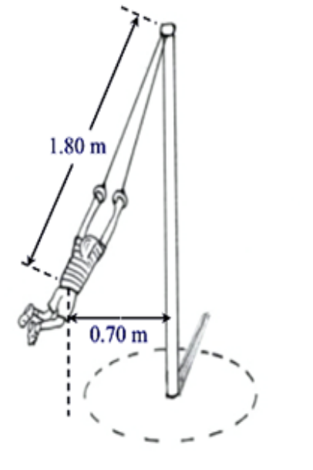Max, a 20.0 kg child, is shown swinging freely around a playground pole such that his centre of mass is always located 1.80 m from the top of the pole and 0.70 m horizontally away from the pole.

Calculate the forces acting on Max, and show these forces on the diagram at right, clearly labelling their sizes and directions.
[6 marks]

END OF SECTION ONE
SECTION TWO: PROBLEM-SOLVING

This section has SIX (6) questions. Attempt ALL questions. Answer in the spaces provided.

Allow approximately 80 minutes to complete this section [70 marks].

Question 14
The two speakers shown in the diagram below each emitted the same 440 Hz note. The speakers were in phase with each other.
39 cm
Q₁ Q₂
Speaker 1
Speaker 2

While walking from Speaker 1 to Speaker 2, Sam noticed that the sound varied in loudness, with both loud and quiet locations. Using a sound level meter, Sam fixed the locations of two adjacent quiet spots, shown above as Q₁ and Q₂. The distance between Q₁ and Q₂ was recorded as 39 cm.

- Explain briefly why these quiet spots occurred between the speakers.
[3 marks]

- Sam wants to reduce the uncertainty of the position measurements.
(i) To do this, Sam should:

A. decrease the volume (loudness) of the sound emitted by the speakers.

B. measure the distance between several quiet spots.

C. increase the number of significant figures when writing down the distance measurement.

D. decrease the distance between the speakers.

Answer

[1 mark]

(ii) Explain how the above change would reduce uncertainty.
[3 marks]

- Calculate the speed of sound on the day when Sam made the measurements.
[3 marks]

Question 15
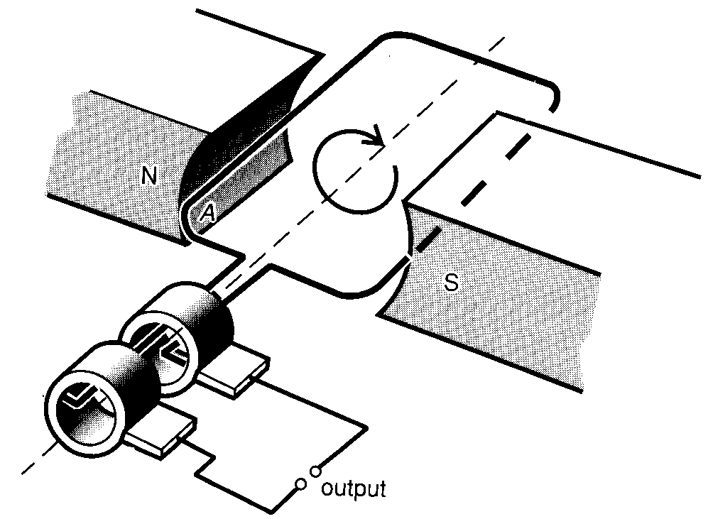
Anne's bicycle has an electric generator attached to the rear wheel to provide power for a headlamp. The bicycle wheel rubs against the barrel of the generator, causing it to rotate. Inside the generator there are 400 turns of wire forming a coil with an average area of 140 mm². The coil rotates between the poles of a permanent magnet.

When Anne rides the bicycle at 4.5 m s⁻¹ the generator rotates at 83.3 revolutions per second and generates an output voltage of 4.4 V AC across the lamp, whose resistance is 1.1 Ω. under these conditions:

- (i) What is the frequency of the AC output voltage generated?
[1 mark]

(ii) Calculate the power that is provided to the lamp.
[2 marks]

- Calculate the approximate magnetic field strength passing through the coil.
[6 marks]

- Explain how a suitable commutator could change the output of the generator from AC to DC. You may use a labelled diagram to clarify your response.
[3 marks]

Question 16 (13 marks)
Playing a hard game of tennis, Bridget hits a ball at an angle of 1.50° above the horizontal at a speed of 55.0 m s⁻¹. At the instant she hits the ball; it is 0.350 m above the ground.

- (i) Sketch the trajectory (path) of the ball from the racquet to the ground, without air resistance.
[2 marks]

(ii) On the same sketch, show how air resistance will affect this trajectory. Label your sketch clearly.
[1 mark]
(iii) Explain why air resistance has this effect.
[2 marks]

(iv) Is there any time at which the ball will have zero acceleration between the time it is hit and the time it reaches the ground? Give a reason for your answer.
[2 marks]

Circle the best answer: YES NO INSUFFICIENT DATA SUPPLIED
Reason:

- Ignoring air resistance:

(i) Calculate the time the ball is in the air from the moment it is hit to the time it reaches the ground.
[3 marks]

(ii) Calculate the horizontal distance travelled in this time.
[3 marks]

Question 17
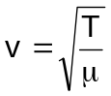Geraldine was investigating the speed of waves along stretched strings. She generated these waves by plucking a 0.760 m length of guitar string. She knew the speed was given by:

Where T is the tension in the string and μ is the mass per unit length. She plotted her results in the graph below:
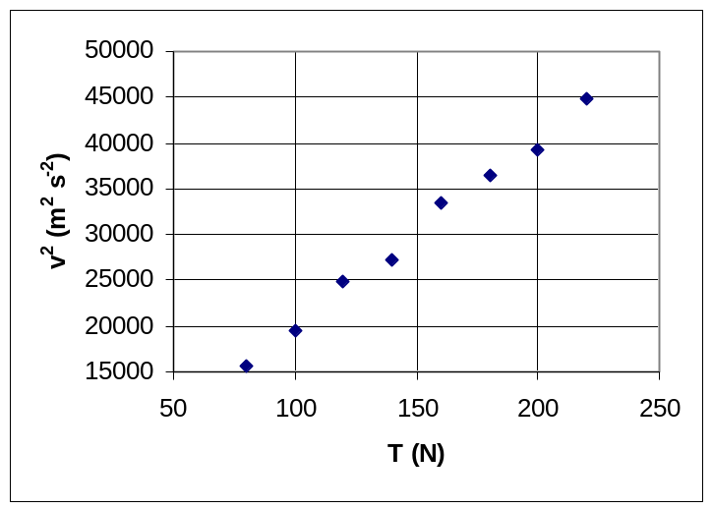

Figure 5: Geraldine’s experimental results

- (i) Why did Geraldine plot v² against T and not just v against T?
[2 marks]

(ii) Determine the units of μ.
[2 marks]

- Use the graph to determine the best experimental value of μ for this string. Show your working clearly.
[5 marks]

- Geraldine adjusted the tension to 125 N. Determine the new frequency of the fundamental mode of the string. Show how you obtain the figures you use.
[3 marks]

Question 18
An electromagnetic pump is a device which can pump solutions containing positively and negatively charged particles through non-metallic tubes. Blood is one example of such a solution.

The principle on which an electromagnetic pump operates is shown in the diagram below. For convenience, the tube is shown as having a rectangular cross-section.

V
B

Two metal plates are placed on opposite sides of the tube, and a potential V is applied between them so that the charged particles in the blood begin to flow across the tube. At the same time, a magnetic field B is applied at right angles to the electric field produced by the plates.

- Indicate on the diagram below the motion of the positively charged particles in the blood. (You are looking down on the tube in the above diagram; that is, you are looking in the direction of the magnetic field B.)
[2 marks]

B into page
+
_
X
X
X
X
X
X
X
X
X
X
X
X
- Indicate on the diagram below the motion of the negatively charged particles in the blood. (You are again looking down on the tube in the above diagram; that is, you are looking in the direction of the magnetic field B.)
[2 marks]
B into page
+
_
X
X
X
X
X
X
X
X
X
X
X
X

- Briefly describe how this pump makes blood flow through the tube.
[5 marks]

- Does the pump use the electric field, the magnetic field, or both fields to transfer energy to the blood? Explain.
[3 marks]

Circle the best answer: electric field magnetic field both fields
Reason:

Question 19
- The diagram shows some of the energy levels of sodium. (Only the lowest energy level shown is occupied by an electron when the atom is in its ground state.)
____________________ 0eV
____________________ -1.009
____________________ - 1.372

____________________ -1.935

-3.026

-3.028

____________________ -5.130

- What is the minimum energy of a photon
that can ionise a sodium atom?
[1 mark]

Answer: ____________ eV

- What process does the arrow drawn in the diagram represent? What is the result of the process?
[3 marks]

- (i) Two lines in the sodium spectrum resulting from electron transitions to the ground state in the yellow region are very close together. Explain how this light is produced. Hence estimate the wavelength of yellow light.
[3 marks]

(ii) Identify on the diagram a transition which will cause the emission of a photon with a wavelength longer than for yellow light. State the reason you selected this transition.
[2 marks]

- Explain how the spectrum of light from a vaporised sample of a mineral can be used to identify elements in the mineral.

[2 marks]

END OF SECTION TWO
SECTION THREE: COMPREHENSION

This section has TWO (2) questions. Attempt ALL questions. Answer in the spaces provided.

Allow approximately 50 minutes to complete this section [35 marks].

Question 20

For copyright reasons this graph cannot be reproduced in the online version of this document.
USING X-RAYS
- When metals are bombarded with high-speed electrons they can emit X-rays. For example, when electrons of a particular energy are fired at a molybdenum target, a range of X-rays of different wavelengths are produced—as shown in the graphical spectrum on the right. Many metals produce a similarly shaped spectrum.

[Graph from: Walker, 2004]

(i) Explain how the X-rays are produced. In particular, explain the origin of the peaks
in the X-ray spectrum (labelled K_{α} and K_{β}).
[3 marks]

(ii) The electrons fired at the molybdenum target are accelerated by a high potential difference. Which of the potential differences below would most likely have produced the above X-ray spectrum? Justify your answer.
[3 marks]

Circle the best answer: 15 kV 35 kV 50 kV
Reason:

- In 1914, a physicist called Henry Moseley tested the X-rays produced by different target metals and found that there was a relationship between the wavelength of the peak marked K_{α} and the atomic number (Z) of the metal. The relationship is expressed in the following equation:
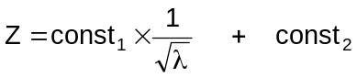
where λ is the wavelength of the K_{α} peak.

This equation has the general form:
y = mx + c
which means that if Z is graphed against 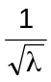, the result will be a straight line. The following experimental data might have resulted from experiments like Henry Moseley conducted.

Element | Atomic Number (Z) | Wavelength (pm) | Wavelength (m) | (m^{-½})
Molybdenum | 42 | 54
Tin | 50 | 38
Barium | 56 | 30
Ytterbium | 70 | 19
Tungsten | 74 | 17
Platinum | 78 | 15
Lead | 82 | 14

(i) The wavelengths in the table above are given in units of pm. Convert all wavelengths to metres (column 4) and calculate appropriate values for column 5.
[4 marks]

(ii) Use the data to produce a graph of Z vs , with Z on the vertical axis.
Do this on the graph paper provided.
[3 marks]
Question 20 (cont.)

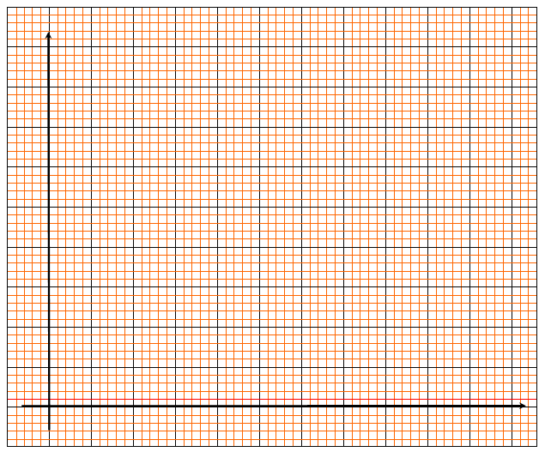
- (i) Determine the gradient of the line of best fit (the regression line).
[2 marks]

Gradient = ________________________________________

(ii) How many significant figures should you use for value of the gradient?
Explain.
[2 marks]
Reason:

- The actual equation of the straight line is:
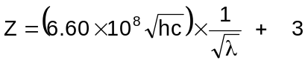
where c = speed of light and h = Planck’s Constant.

Use the gradient you determined in part (c) to work out an experimental value for Planck’s Constant, h.

(If you were unable to work out a gradient, use the value 2.5 x 10⁻⁴)
[3 marks]

Question 21
MEASURING THE EARTH’S TEMPERATURE
(Paragraph 1)
Thermometers have only been used for routine measurement of daily temperature changes over the last 150 years or so. To understand long-period cycles in the Earth’s surface temperature, scientists had to work out how the Earth itself records temperature changes. It turns out that the ratio of two isotopes of oxygen, for example in calcium carbonate deposits in seashells and caves, depends strongly on the average temperature. The ratio of 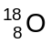 to 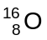 is the key to such measurements. This ratio changes in a predictable and measurable way as the temperature changes. A complication is that higher temperatures increase the to ratio in rainfall, but decrease the ratio in calcium carbonate deposits such as in caves.

(Paragraph 2)
Measuring the ratio of isotopes of an element is not simple, and depends on being able to weigh individual atoms with some accuracy. A common tool used for this purpose is the mass spectrometer. In this device, the atoms to be measured are firstly ionised by an electron beam. In one type of mass spectrometer, the positive ions produced by this process are then accelerated so they all have the same velocity. In the diagram, this takes place in the ion source.
Schematic diagram of a mass spectrometer
Ion source
Ion detector
Strong magnetic field perpendicular to page
Ion 1
Ion 2

(Paragraph 3)
These fast moving ions then enter a magnetic field, which makes them follow a curved path that is an arc of a circle. Because the magnetic field intensity, the ion velocity and the ion charge are all constants, the radius of the curve followed by any one ion depends only on its mass. The mathematical relationship is:
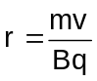
where r is the radius of the ion path, m is the ion mass, v is the ion velocity, B is the magnetic field strength, and q is the ion charge. The point where the ions strike the detector tells the scientists the ion mass. Scientists can work out the isotope ratio from the relative number of ions striking the detector in any one place.

- Is the magnetic field shown in the diagram directed into the page, or out of the page?
[1 mark]

Circle the best answer: into the page out of the page could be either

- Which of the two ions shown in the diagram above (ion 1 or ion 2) is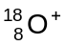? Justify your answer.

Circle the best answer: ion 1 ion 2
[3 marks]
Reason:

- The positive ions, 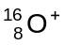 and are produced by directing a beam of electrons onto gaseous atoms of oxygen. Explain how electrons can create positively charged ions.
[1 mark]
_______________________________________________________________________________

_______________________________________________________________________________

_______________________________________________________________________________

_______________________________________________________________________________

_______________________________________________________________________________

_______________________________________________________________________________

- (i) The initial acceleration of the ions in the ion source of a mass spectrometer is caused by an electric field. Show the orientation of this field in the diagram below.
[1 mark]
Ions created here
Accelerating electric field
Ions exit here

Question 21 (cont.)

(ii) An ion has a charge of +1.6 x 10⁻¹⁹ C and is accelerated by a potential difference of 25 kV. Calculate its final kinetic energy.
[2 marks]

(iii) The velocity of the ion described in part (ii) above is 5.49 x 10⁵ m s⁻¹. This ion has a mass of 2.656 x 10⁻²⁶ kg. Calculate the radius of its path if the magnetic field in the mass spectrometer has an intensity of 8.0 tesla.
[3 marks]

- Scientists taking ice cores from a mountain glacier date one sample as 20 000 years old. Another group takes samples of calcium carbonate from a cave on the same mountain. They also date these samples as 20 000 years old. If both groups determine the to ratios of their samples, discuss briefly whether the samples are likely to differ. Give reasons for your answer. (Paragraph 1)
[4 marks]

END OF PAPER
This blank space has been provided for additional workings.

This blank space has been provided for additional workings.

ACKNOWLEDGEMENTS

SECTION C

Question 20: Graph from: Walker, J.S. (2004). Physics (2nd ed.). Upper Saddle River, NJ: Pearson Education.
Published by the Curriculum Council of Western Australia
27 Walters Drive
OSBORNE PARK WA 6017

